Name: Ritika Mohan
Prn: 23070521183
Semester: 5th C (C1)
Aim: Conditionals, Loops & User Input:
Use if-else, switch-case, and looping constructs like for, while, do-while. Accept input through forms and perform validation. Create a grading system that classifies grades based on marks entered by the user.
Output:
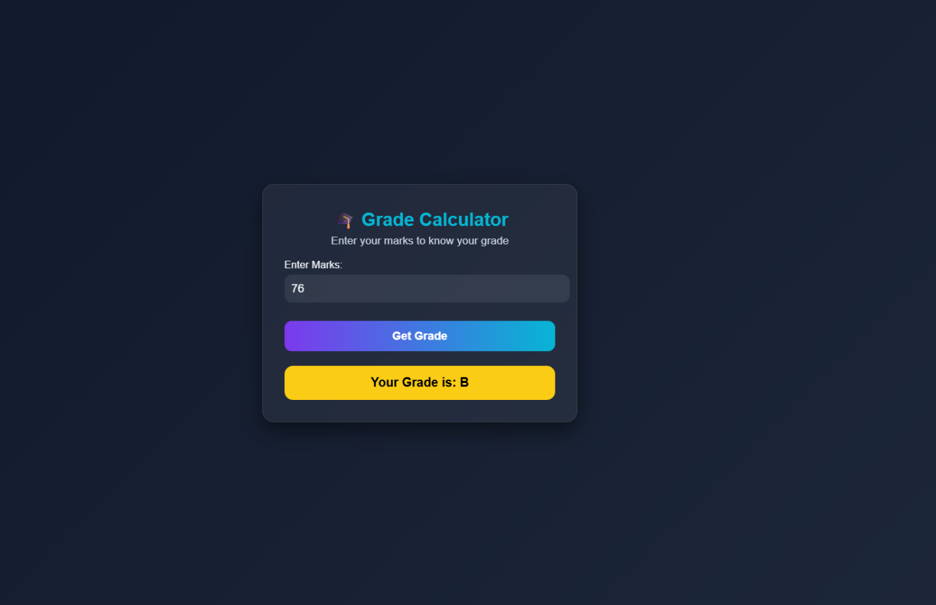
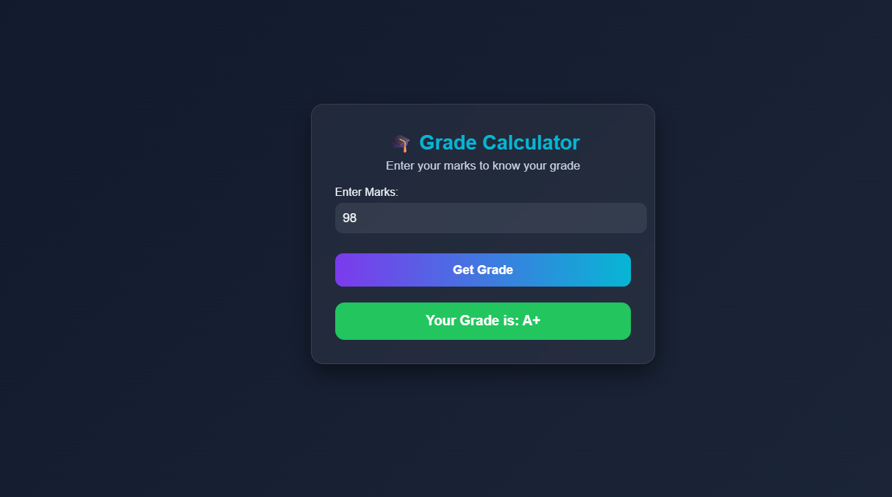
Theory
- Conditional statements are used to make decisions in programs.
- Conditional Statements in Javascript:
  - if statement → Executes a block if condition is true
  - if…else → Executes one block if true, another if false
  - else if → Checks multiple conditions sequentially
  - switch → Alternative to multiple if–else
Case Study
- Input: Marks entered by user
- Conditions:
  - 50–65 → Grade C
  - 66–80 → Grade B
  - 81–90 → Grade A
  - 90 → Grade A+
  - Otherwise → Fail
- Used if–else ladder to check ranges and display grade.
- Added color-coded results using CSS for better visualization.

Conclusion: Created a grade generator that gives output Grade “C” if entered marks are between 50-65, “B” for 66-80 and “A” for 80-90 and “A+” for above 90.

